Model Name | SKU Name 1  SKU Name 2
Sample Requirement | EVT: 2 per SKU (For PD use)  DVT: 5 per SKU (For PD use)
Target BOM cost | USD xxx
Target Release Date | YYYY/MM/DD

Wesley Gu(辜紹桓)
wesley.gu@cypress.com.tw

Android Controller PAD
Model Name(TBD)
Ver : | 0.2
Date : | 2026/3/17

Last Update Date: 2026-03-17
Revision History

Ver. | Date | Update by | Change Summary
0.1 | 2026-03-12 | Wesley | Preliminary Release
0.2 | 2026-03-19 | Wesley | Updated function map and function descriptions for clarity and consistency

BASIC INFORMATION

Category
Division | DV
Control | TBD

Model Name | Hier ID | Product hierarchy
TBD | TBD | Master_Control Pad_Desktop

SKUs
- TBD Android Controller PAD

內容
1 Introduction 2
1.1 Overview 2
1.2 Feature 2
1.3 Launch Information 2
1.4 Compatible Products 2
2 Applications 2
2.1 Applications 2
2.2 Use Cases 2
3 INTERFACE AND SPECIFICATION 2
3.1 Front Panel 2
3.1.1 Front Panel Layout Concept 2
3.1.2 Front Panel Description 2
3.2 Rear Panel 2
3.2.1 Rear Panel Layout Concept 2
3.2.2 Rear Panel Description 2
4 General Block Diagram 2
5 System Feature 2
5.1 System Feature 2
5.2 Performance Requirement 2
5.3 Electrical Requirement 2
5.4 Software/Firmware Requirement 2
6 Video 2
7 Audio 2
8 Control User Interface 2
9 Mechanical 2
9.1 Mechanical 2
10 Regulatory Compliance 2
10.1 Regulatory 2
10.2 Environmental 2
10.3 MTBF 2
11 Packaging and Accessory 2

Introduction

Overview
This document defines the Product Requirements Document (PRD) for the Android Controller Pad system. The product is a dedicated control terminal built on the Android platform, designed for commercial and Pro AV environments to provide centralized device control, scenario management, and scheduling capabilities.
The Android Controller Pad operates in Kiosk Mode, ensuring the device automatically launches into the control interface at boot and maintains a stable, dedicated user environment. The device supports PoE+ for simplified installation and deployment, and provides both wired Ethernet and Wi-Fi connectivity to accommodate flexible network infrastructures.
The system integrates a touch-based user interface with an embedded WebGUI management platform, allowing system integrators to configure and manage the device through a web browser, while end users interact with a friendly control interface.

Feature
- Android-based 8’’/10’’/15’’ touch panel as the controller platform.
- Supports Power over Ethernet (PoE+) for both power supply and network connectivity.
- Includes a built-in WebGUI that allows system integrators to configure devices, commands, macros, and UI layouts.
- Supports configure automation macros that execute command sequences with delay, scheduling, and conditional logic to control multiple devices simultaneously.
- Provides a device driver library that simplifies device integration and enables scalable device management.
- Allows users to design customized control interfaces with configurable buttons, icons, templates, and themes.
- Provides template-based UI layouts, such as for light and speakers, to enable quick deployment of control interfaces.
- Operates in kiosk mode to ensure the controller pad runs as a dedicated control interface.
- Supports extendable multilingual user interfaces including Chinese, English, Japanese, and more.
- Supports both Ethernet and Wi-Fi network connectivity.
- Provides password protection for secure system management.
- Supports firmware upgrade through OTA updates and local upgrade mechanisms.
- Supports watchdog monitoring and recovery mechanisms to ensure stable long-term operation.
- Supports receiving external commands as event triggers to execute built-in events, macros, or commands for coordinated control of multiple external devices.

Launch Information
- Target Market: Commercial / Residential / Medical / Broadcast / …
- Launch Show: InfoComm 2027
- Delivery Dates: August 2027

Compatible Products
- Pro AV Products
- Environmental equipment

Applications

Applications
- Environmental Device Control
- Professional AV Equipment Control
- Meeting Room Automation
- Smart Conference Room Control Panel
- Room Scenario Control

Use Cases
- Use Case 1 — Meeting Room Startup
A user presses the “Meeting Start” button on the controller pad, triggering a predefined macro that powers on the projector and displays, selects the presentation source, and adjusts room lighting to presentation mode.
- Use Case 2 — Source Switching During Presentation
During a meeting, the presenter selects a different input source from the controller interface, and the system sends commands to the AV switcher and display devices to change the presentation source.

- Use Case 3 — End of Meeting Shutdown
At the end of a meeting, a user presses the “System Off” button, executing a shutdown macro that powers off AV equipment and restores the room environment to its default state.

INTERFACE AND SPECIFICATION

Front Panel
NO | Item | Type | Description
1. | Touch Display Panel | Hardware | The device shall include an 8/10-inch touch display panel used as the primary user interface for system control.
2. | Touchscreen | Multi-touch | The display shall support capacitive multi-touch input for responsive user interaction.
3. | Display Resolution | LCD Panel | The display shall provide sufficient resolution to clearly present control buttons, icons, and system information.
4. | Screen Brightness | Display Control | The display shall support adjustable brightness to ensure readability under different lighting conditions.

Rear Panel
NO | Item | Type | Description
1. | Power input | DC Power | Provides a DC power input connector for powering the device when PoE+ power is not used.
2. | RJ45 | Ethernet Network Port | Ethernet RJ45 support 10/100 Mbps and power supply via PoE+.
3. | USB 3.0  (Type-A) | USB Service Port | Provides a USB interface for system maintenance such as firmware upgrade, log extraction, or local configuration.
4. | Reset Button | Button | A physical button used for system operations such as rebooting the device or performing a factory reset.
5. | RS-232 Port | Control Interface | Provides a serial control interface for communication with external devices.

General Block Diagram
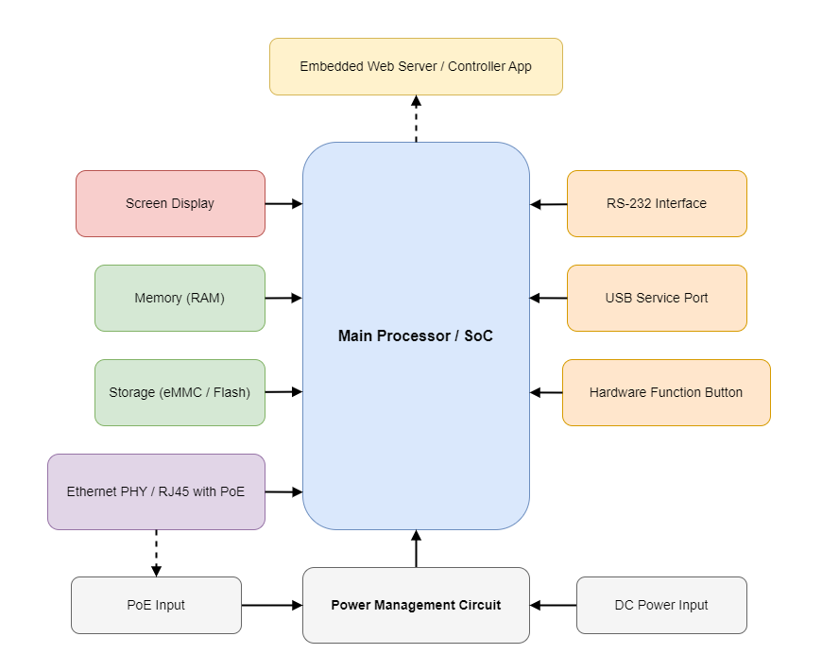

System Feature

Firmware/Software Functional Map

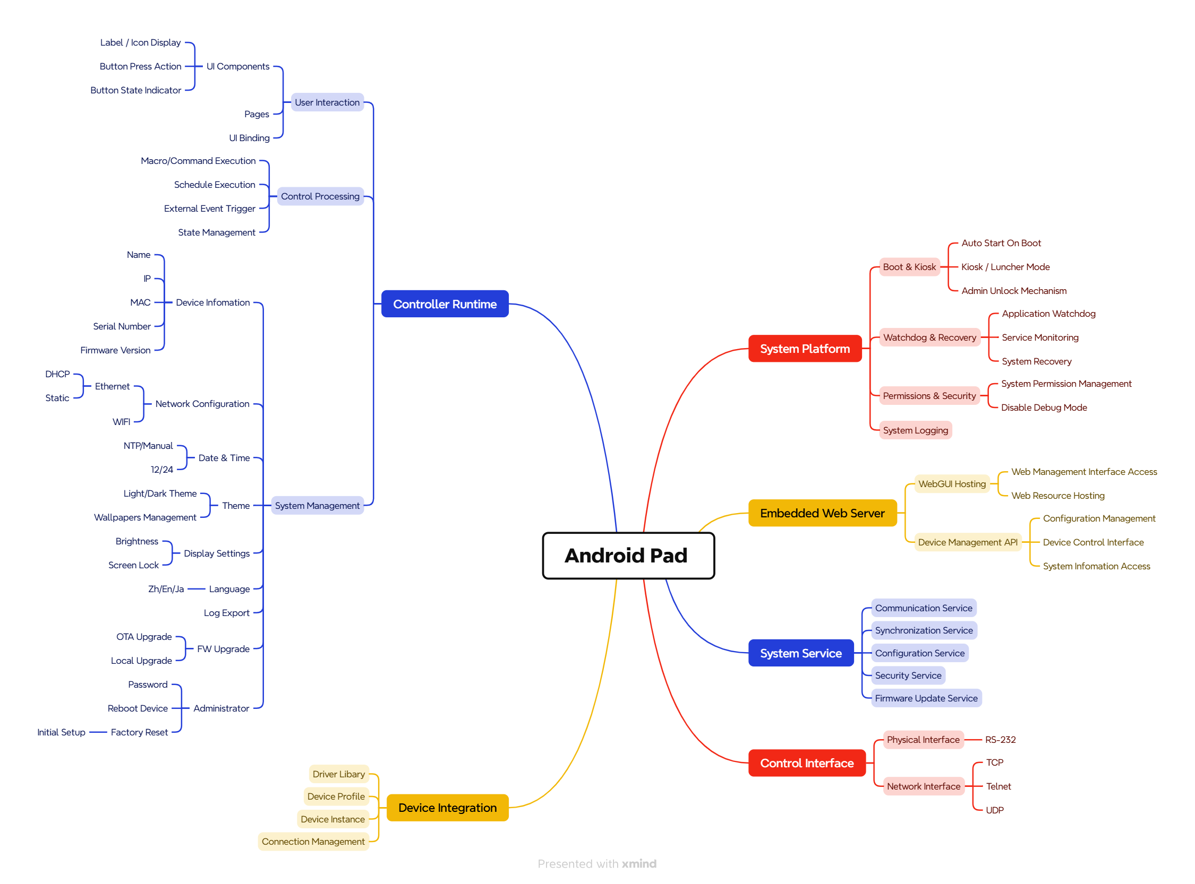
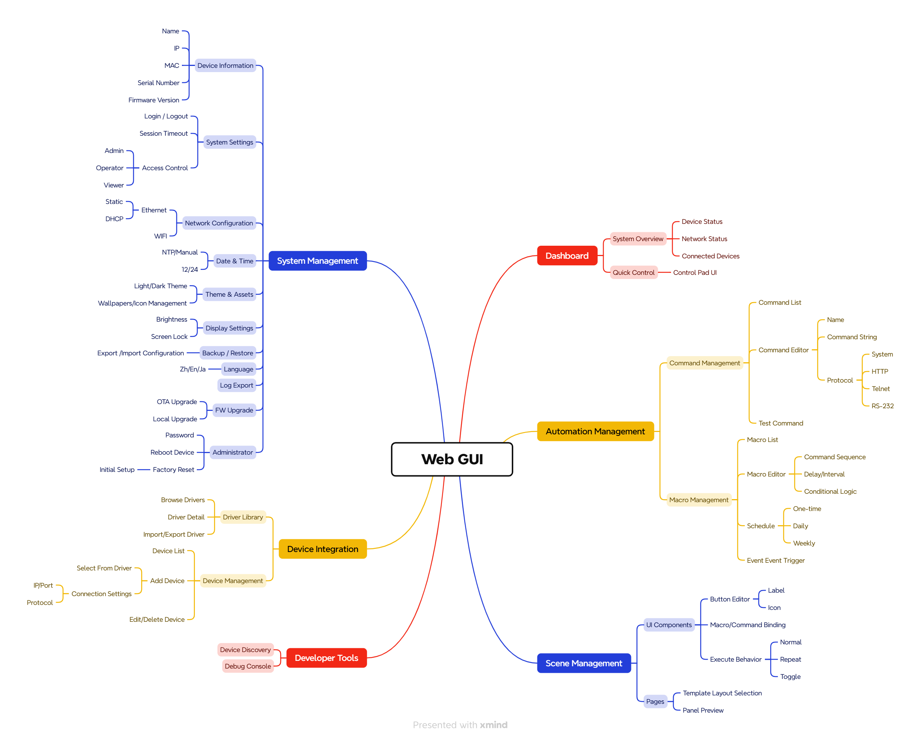

Firmware/Software Requirement

Firmware Function List
NO | Item | Description | Note
 | Fast System Boot Time | The system boots into the controller application within the target startup time, allowing the device to become operational quickly after power-on.
 | Auto Launch Application | The control application automatically launches after system boot, ensuring the device always operates as a dedicated control panel.
 | Kiosk Mode Operation | The system runs in kiosk mode to restrict access to the Android system.
 | Device Firmware Management | Supports OTA and local firmware upgrades with progress monitoring and failure recovery.
 | System Permission Management | Manages required Android system permissions for the controller application to ensure proper access to system resources and secure system operation.  Disable debugging interfaces for production security.
 | Factory Reset | Allows administrators to restore the device to factory default settings through the Web GUI or by long-pressing the hardware reset button.
 | System Reboot | Supports system reboot through the Web GUI or system management interface.
 | Watchdog Monitoring Mechanism | Provides watchdog monitoring that can automatically restart the control application or system services when abnormal behavior is detected.
 | System Logging | Records system logs for troubleshooting and maintenance purposes.
 | Screen Saver | The system shall activate a screen saver after a configurable inactivity period (default: 10 minutes).  The screen saver shall be dismissed upon user interaction. If password protection is enabled, a password prompt shall be required to unlock.  Supported content includes clock, branding, and custom images.
 | Standby Mode | The system shall enter standby mode after a configurable inactivity period (default: 2 hours).  The device shall enter a low-power state and resume upon user interaction.
 | Control Interface | Provides hardware and network-based control interfaces including RS-232 and IP protocols (TCP, Telnet, UDP) to support communication with a wide range of AV and environmental devices.
 | Network Priority | The system is designed to prioritize wired Ethernet connectivity, while Wi-Fi is provided as a secondary or commissioning interface for flexible deployment.
 | System Service | Provides core system services that support device communication, configuration synchronization, security control, firmware management, and system monitoring for the controller platform.

Controller Application Function List
NO | Item | Description | Note
 | Boot Auto Start | Automatically launch the controller application after system boot.
 | Landscape UI | Provide landscape UI mode support for panel usage.
 | Embedded Web-Based Configuration Interface | Includes an embedded web server that hosts the Web GUI, allowing system integrators to configure devices, commands, macros, UI layouts, and system settings through a standard web browser.
 | Control Processing | Provides a centralized control processing mechanism that manages commands and macros, enabling execution of command sequences with configurable logic such as delay, repeat, and sequence. Supports automation through schedules and event-based triggers, allowing coordinated control of multiple devices.
 | User Interaction | Provides a user-facing control interface that includes configurable UI components, page structures, and UI binding mechanisms.  Supports UI buttons with customizable actions (command or macro execution), visual state indicators, and page navigation to ensure clear feedback and intuitive operation.
 | Driver Library | Provides a library of device drivers that define communication protocols and control commands for supported devices.
 | Device Instance Management | Allows users to create and manage device instances based on drivers and configure connection parameters such as IP address, port, and communication protocol.
 | Multi-Protocol Device Control Support | Supports device communication protocols including HTTP, Telnet, RS-232, and internal system commands.
 | Initial Setup Wizard | Provides a guided setup process during the first boot or after factory reset for network, language, and system configuration.
 | Configuration Synchronization Mechanism | Ensures bidirectional synchronization of configuration settings between the Web GUI and the controller pad.
 | Configuration Backup and Restore | Allows users to export system configuration for backup and restore it when necessary.
 | Security and Administrative Access Control | Provides password protection for system configuration and a secure method for administrators to exit kiosk mode for maintenance.
 | Log Export | Allow exporting logs for support and troubleshooting.

WEB GUI Function List
NO | Item | Description | Note
 | Dashboard Overview | Provide a system dashboard displaying device status, network status, and connected devices.
 | Quick Control Interface | Provide a quick access control interface for triggering control actions directly from the dashboard.
 | User Authentication and Access Control | Provides user authentication with login/logout, session timeout, and role-based access control to restrict system configuration and system operations based on user roles.
 | Command Management | Provide command list operations and command editing capabilities, including name, protocol type, and command string. Support command protocols including System, HTTP, Telnet, and RS-232.  Allow users to test command execution before saving or assigning it.
 | Macro Management | Provide macro list operations and macro editing capabilities. Allow users to build macros by arranging command sequences. Support configurable delays/intervals between commands in a macro. Allow conditional execution logic inside macros.
 | Scheduling | Allow macros to be executed by one-time, daily, or weekly schedules.
 | Event Trigger | Trigger macros based on predefined events.
 | Scenario Management | Provides customizable control pages with configurable buttons (icon and label) that execute commands or macros with selectable behaviors including normal, repeat, and toggle.
 | Template Layout | Allow users to select and apply UI layout templates.
 | Panel Preview | Provide a preview of the control pad UI before deployment.
 | Theme & Assets | Manage themes (light/dark) and assets (wallpapers/icons).
 | Driver Library | Provide driver browsing, driver detail, and driver import/export management.
 | Device Integration | Manage device list, add devices via driver selection, and configure connection settings.
 | Device Discovery | Discover devices on the network for faster integration.
 | Debug Console | Provide debugging interface for diagnostics and advanced troubleshooting.

Common System Function List
NO | Item | Description | Note
 | Device Information | Display device information including name, IP, MAC, serial number, and firmware version.
 | Network Configuration | Support Ethernet configuration including DHCP and static IP. Support Wi-Fi configuration for network connectivity
 | Date & Time Settings | Support NTP-based automatic time and manual time configuration. Support 12/24-hour time format.
 | Display Settings | Support brightness configuration and screen lock behavior.
 | Password / Access Protection | Provide password settings for securing system/settings access.
 | Language Selection | Support extendable multilingual UI including Chinese, English, and Japanese.
 | Firmware Upgrade | Support OTA firmware upgrade and local firmware upgrade via uploaded package/file.  Provide upgrade progress monitoring and status feedback.
 | Reboot | Allow administrators to reboot the device/system.
 | Factory Reset | Allow administrators to factory reset and re-run initial setup flow.

Performance Requirement
NO | Item | Description | Note
 | System Boot Time | The device shall boot and launch the controller application within 30 seconds after power-on.
 | Touch Response Latency | Touch input response time for UI interactions shall be less than 100 ms under normal operating conditions.
 | Concurrent Command Processing | The system shall support sending commands to multiple devices simultaneously without blocking UI operation.
 | System Stability | The device shall support continuous operation for at least 7 days without requiring a reboot.
 | Control System Capacity | The system shall support at least 128 commands, 128 macros, 32 device instances, 64 UI buttons, and 5 scenario control pages for room control applications.

Electrical Requirement
NO | Item | Description | Note
 | Power Input | The device shall support DC power input through a dedicated power connector.
 | Power over Ethernet (PoE+) Support | The device shall support power supply through the Ethernet port using PoE+ to simplify installation.
 | Standby Power Consumption | The device shall maintain low power consumption when the display or system enters standby mode while remaining ready for immediate operation.

Mechanical

Mechanical
NO | Item | Description | Note
 | Mounting Options | Desktop placement. Optional: mounting holes or bracket for permanent installation
 | Pad Color |  | TBD
 | Dimensions | 8”/10”/15’’ Pad

Regulatory Compliance

Regulatory
NO | Item | Description | Note
 | EMC/FCC/IC/RCM | FCC part 15 subpart B, Class B;  EN 55032,  EN 55035,  EN61000-3-2,  EN 61000-3-3,  ICES-003, Class B
 | CE | CE Mark
 |  | EU Energy-related Products directive (ErP) 2009/125/EC.
 | RoHS 2 | RoHS 2 (2011/65/EU), including any amendments or additions made to the restricted substances list.
 | REACH | REACH Regulation 1907/2006/EC, including all additions and updates to the chemical list
 | Prop65 | Prop65
 | Conflict Minerals | Conflict Minerals Regulation (Dodd Frank Section 1502) for Tantalum, Tin, Tungsten and Gold. (3TG)  (http://www.conflictfreesourcing.org/conflict-minerals-reporting-template/)

Environmental
NO | Item | Description | Note
 | Storage temperature | -40 °F to 158 °C (-40 °C to 70 °C)
 | Operate temperature | 32 °F to 122 °F (0 °C to 50 °C), 90% RH, non-condensing
 | ESD protection | up to +/-12 kV (air) and +/-8 kV (contact)  - Acceptable behavior: Streaming stops but regains functionality shortly after.  - Unacceptable behavior: Product fails and needs to manually rebooted to regain functionality.
 |  | The temperature inside the product enclosure must not exceed +70 °C (158 °F) at an external ambient temperature of 50 °C.
 |  | No components shall operate at temperatures higher than the manufacturer’s recommended temperatures for those components.

MTBF
NO | Item | Description | Note
1. | MTBF | This product shall have an MTBF of at least 100,000 hours
2. | MTBF Assumption | - The failure rates prediction is based on Parts Stress method of BellCore-B332 Issue 6 reliability prediction.  - The calculation is based on a serial model, which assumes that any failure of any component results in a system failure. This is the worst-case state.  - The detailed predictions for the system were performed at temperature 25°C and ground, non-mobile environment.  - Stress was assumed 50% for all the components.

Packaging and Accessory
NO | Item | Description | Note

